FIBROMAT®
HEAVY-LOAD POSITIONING TABLES

A powerhouse with an extremely large center hole and very flat design at an optimum price — the FIBROMAT heavy-load positioning tables from FIBRO. When large and heavy fixtures have to be positioned dynamically and precisely, the FIBROMAT modular heavy-load positioning table is the optimum solution. It fits perfectly into automobile body in white, as the heart of work piece storages or in honing centers, for example. The maintenance-free rotary table with lifetime lubrication is driven by a reliable spur gear drive.

Product Image Sequence

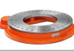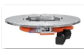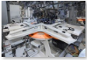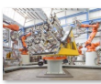

APPLICATION
- For the dynamic and precise positioning of large and heavy fixtures and parts
- For superstructural parts up to 9500 mm
- Ideal for shell and welded design applications
- Deployable as a setup station, large format pallet exchanger and for general handling tasks
- Available as an NC or indexing variant

Benefits
- Heavy-duty positioning table with very large center hole and extremely flat design
- Lubricated for life and maintenance free for highest process reliability
- Perfect power cut and emergency stop behavior through drive with spur gear drive
- Available with many additional options

FIBROMAT®
ADDITIONAL OPTIONS
- Second Drive for higher positioning accuracy and higher torque
- Direct measuring system for highest positioning accuracy up to ±5"
- Machine stand and adaptations, e.g., for the exchange of existing rotary tables
- Expandable center hole by 200 mm
- Indexing unit for increased positioning accuracy of ±15" for freely selectable angles
- Position detection and over-travel protection
- Media distributor and slip-ring transmitter
- Special connecting dimensions and customer-specific drilling templates for your individual use

Images for Additional Features

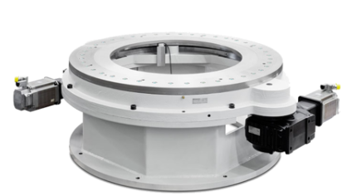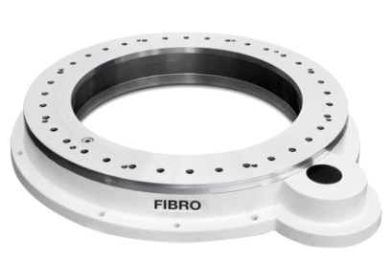

Download
Inquiry form
CATALOGUE
DATASHEET
USER MANUAL
DIMENSIONAL DRAWING
ELECTRIC DRAWING
CAD FILES

